Genetic Algorithm Optimization: A Comparative Study

1. Introduction
This report presents a comparative analysis of genetic algorithm (GA) performance on two benchmark optimization functions: Schaffer Function N.2 and Ackley Function. The study examines different encoding schemes, crossover methods, and population sizes to determine optimal configurations for each function.

2. Selected Functions and Their Plots

2.1 Schaffer Function N.2
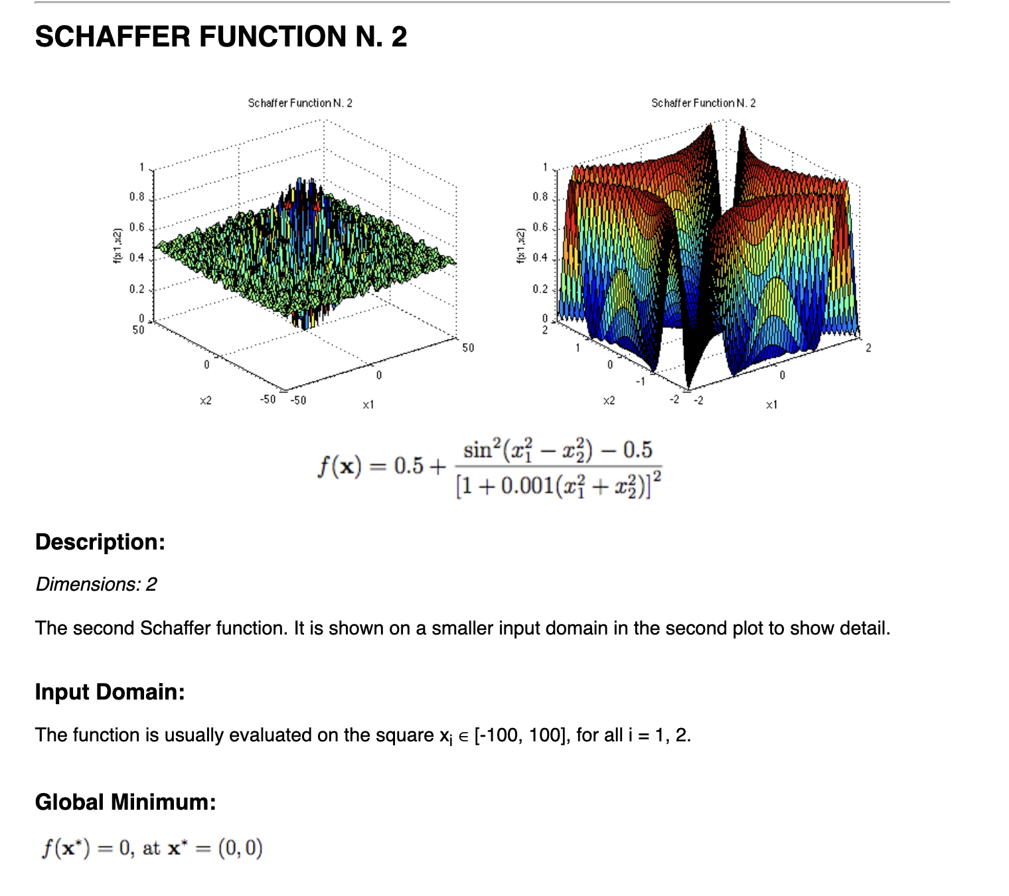
f(x, y) = 0.5 + (sin²(x² - y²) - 0.5) / (1 + 0.001(x² + y²))²
Domain: [-100, 100] for both x and y
Global minimum: f(0,0) = 0
The function features multiple local minima arranged in a circular pattern.
Plotting:
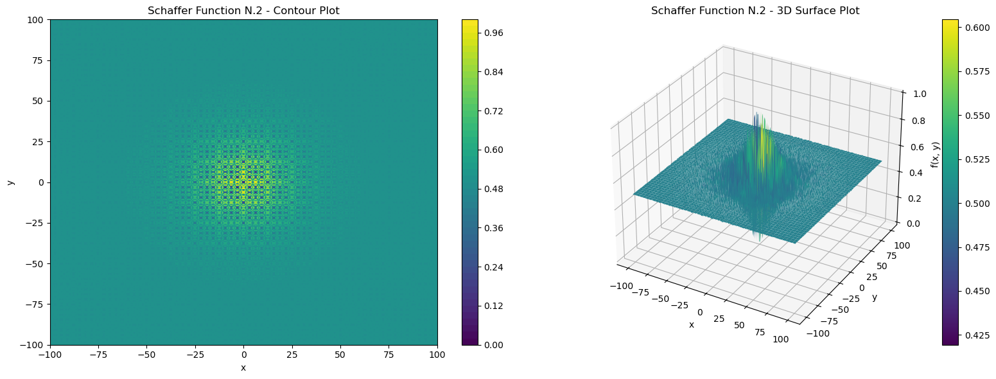

2.2 Ackley Function

f(x, y) = -20 * exp(-0.2 * sqrt(0.5 * (x² + y²))) - exp(0.5 * (cos(2πx) + cos(2πy))) + 20 + e
Domain: [-5, 5] for both x and y
Global minimum: f(0,0) = 0
It is highly multimodal with a flat outer region and a central hole.
Plotting: 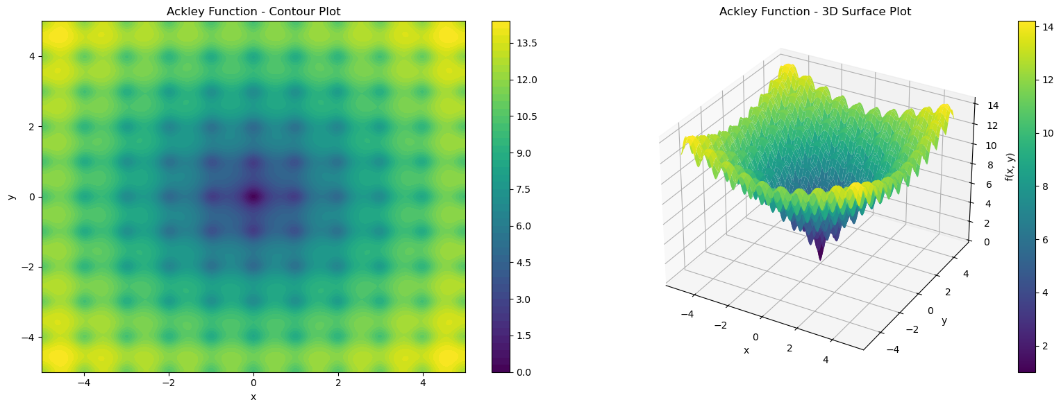

3. GA Configurations

3.1 Encoding Schemes
- Binary Encoding: 16 bits per variable (32-bit chromosome)
- Real-valued Encoding: Direct real-number representation

3.2 Crossover Methods
For Binary Encoding: 1-point and 2-point crossover
For Real Encoding: Arithmetic crossover and BLX-α crossover (α = 0.5)

3.3 Other Parameters
Population sizes: 30, 50, 75, 100, 150
Mutation rates: 0.01 (binary), 0.05 (real)
Crossover rate: 0.9
Generations: 100
Runs: 30 independent per configuration

4. Experimental Results

4.1 Overall Performance Comparison
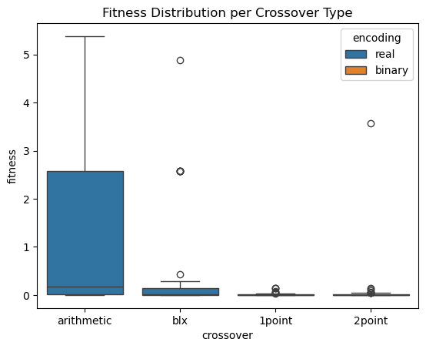
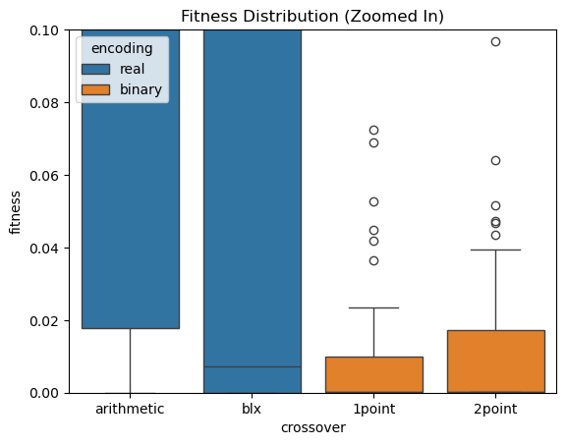
The full-scale boxplot shows variance across encodings and crossover types. The zoomed-in view highlights optimal configurations. Binary encoding outperforms real encoding and binary with 1point crossover has very low and consistent fitness. Real encoding has higher spread and worse medians. Among binary crossovers, 1point is better than 2point, because 2point has more variation and slightly worse performance on average. Real encoding with blx is slightly better than with arithmetic, but still worse than binary.

4.2 Population Size Analysis
Schaffer Function:
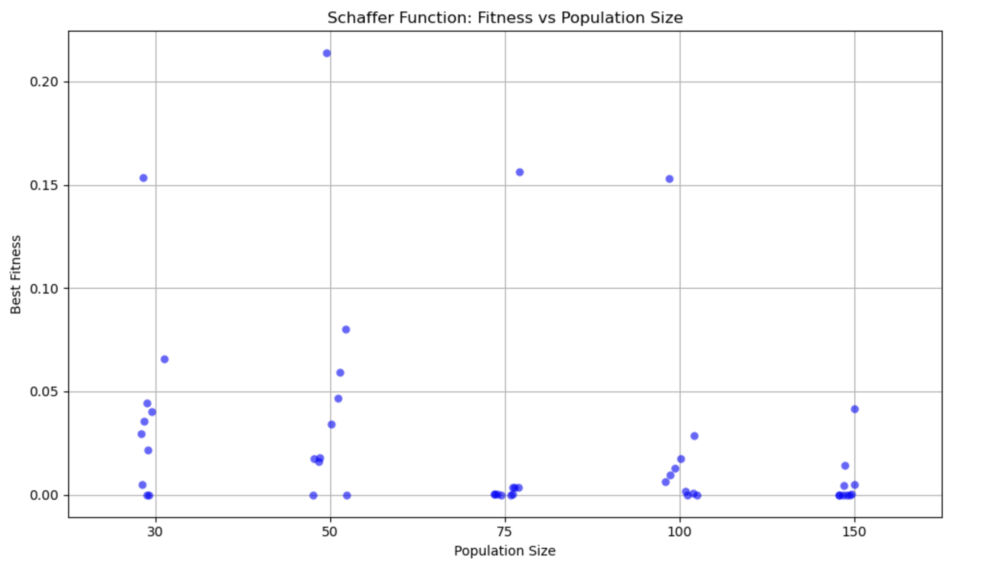
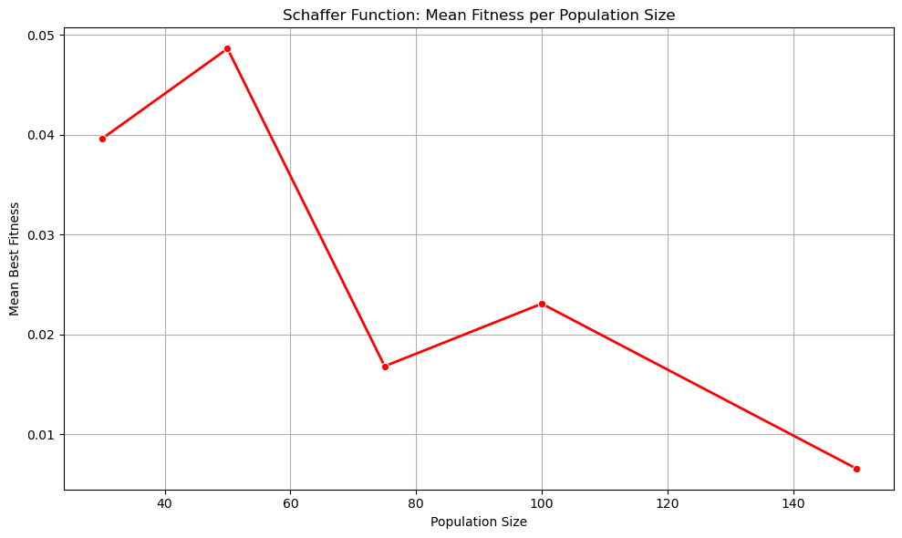
We can clearly observe a higher variance and worse results when the population is small (e.g. 30–50). As population size increases, results become more consistent, best fitness values cluster closer to zero, which is ideal.
There’s a clear decreasing trend: mean fitness drops sharply from 50 to 75, continues to decrease gradually as the population increases from 100 to 150. This confirms that larger populations tend to explore the solution space better and converge toward more optimal solutions.

Ackley Function:
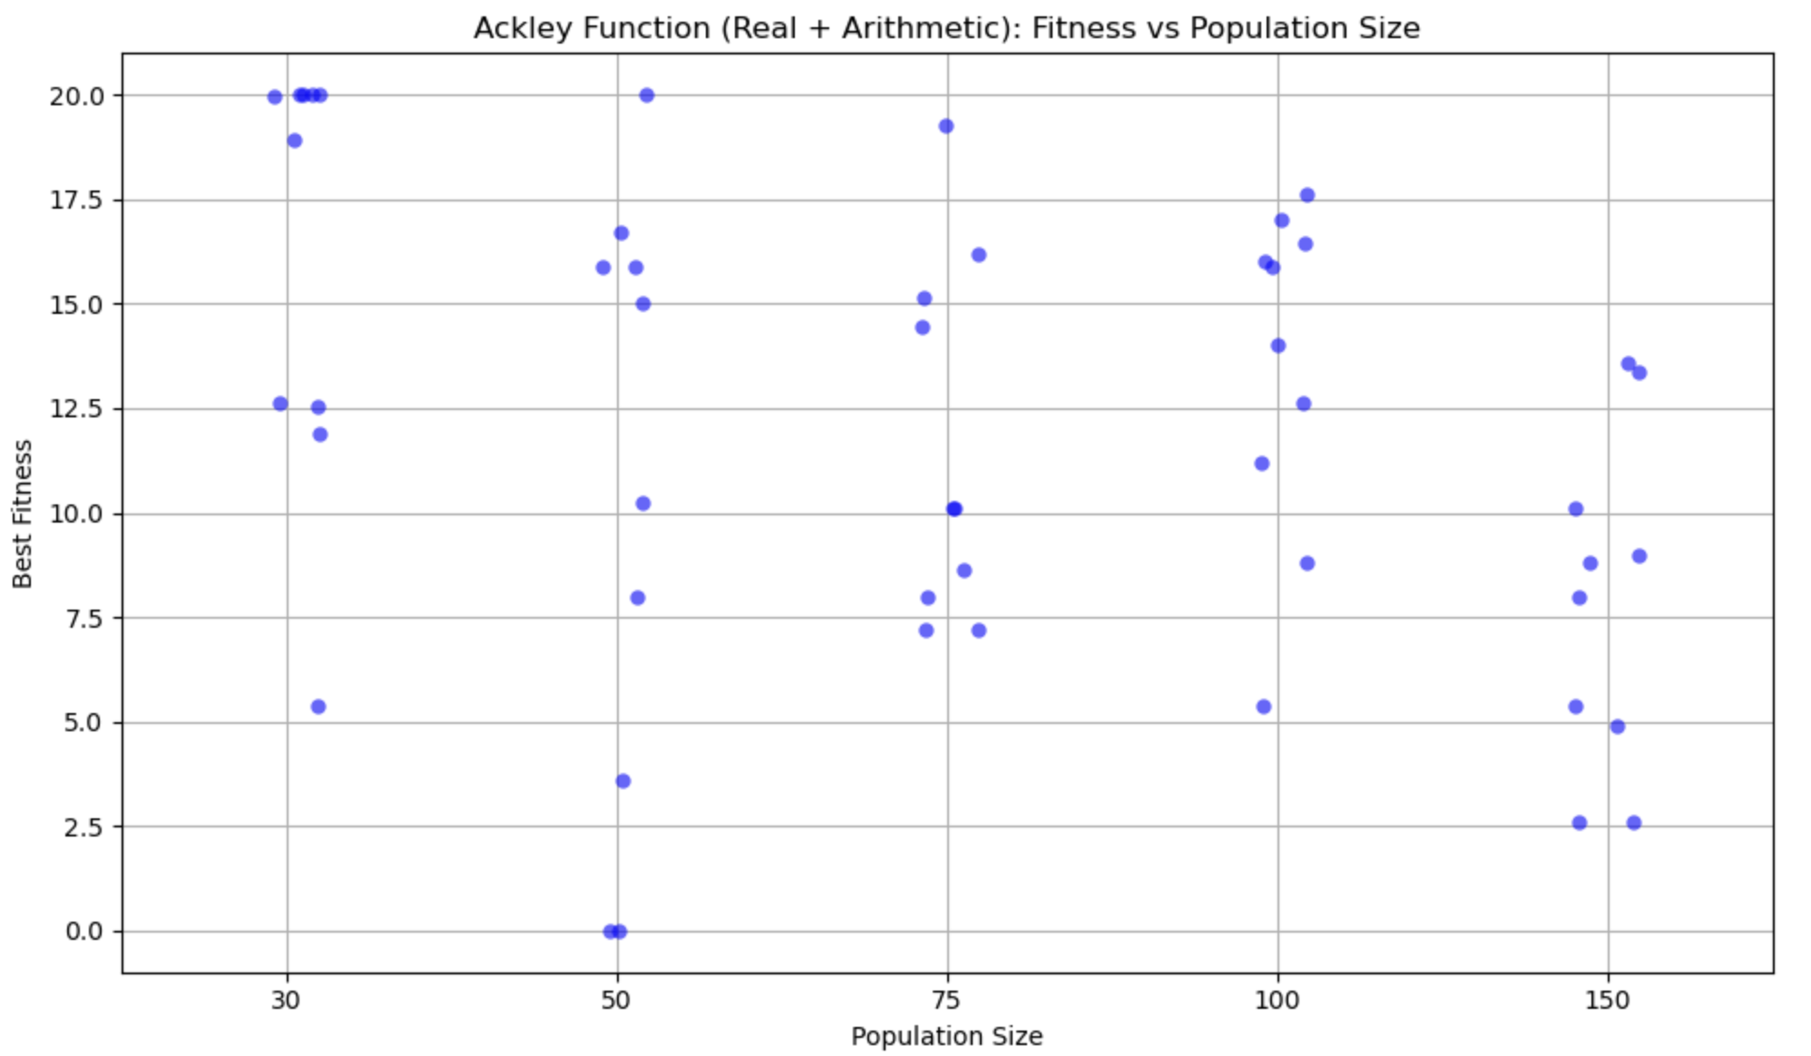
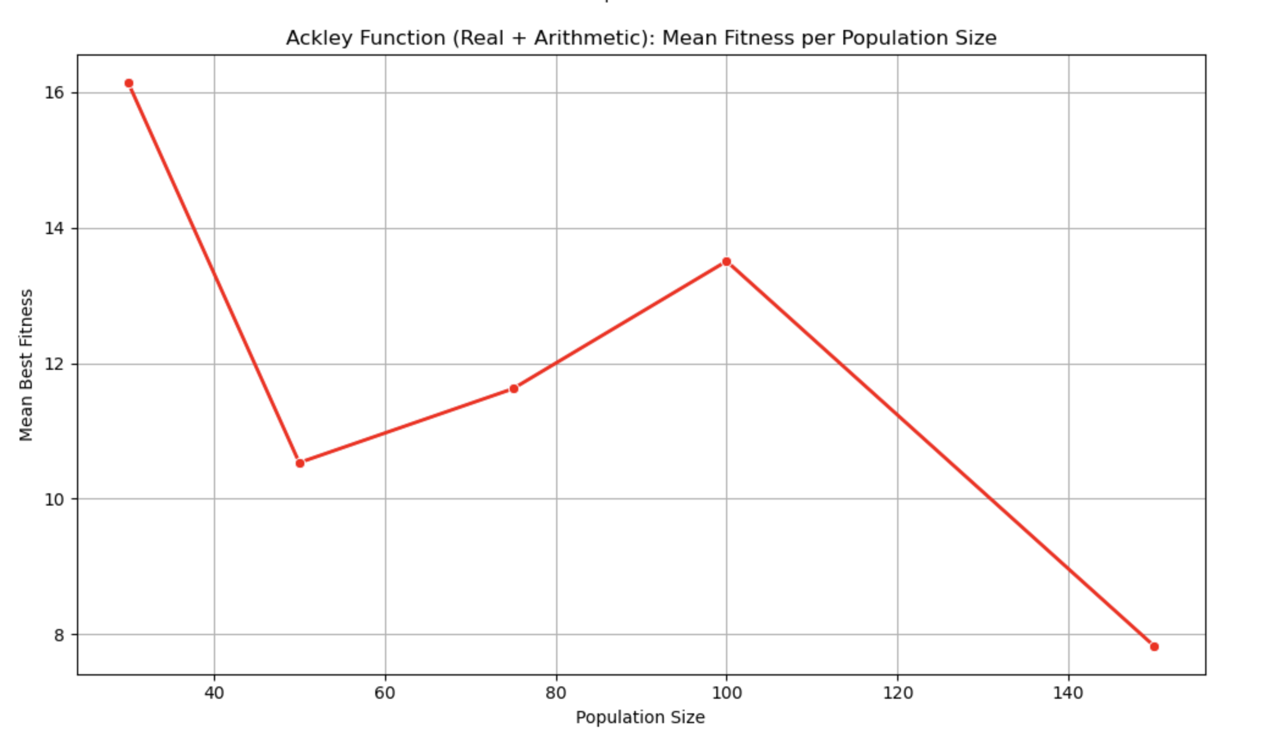

4.3 Summary statistics
To assess the reliability and performance of each genetic algorithm configuration, we computed summary statistics for the best fitness achieved over 30 independent runs per setup. The table below summarizes the mean, standard deviation, minimum, and maximum fitness values.
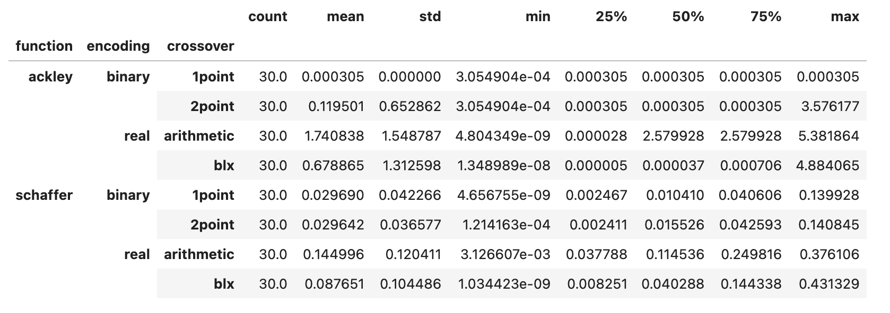
We deduce that:
-For Ackley, binary encoding with 1-point crossover achieved perfect convergence (zero variance) to the global minimum across all runs.
-For Schaffer, binary encoding (both 1-point and 2-point) delivered the best performance, with low mean fitness and small variation.
-Real encoding showed higher variance across both functions. Among real methods, BLX crossover consistently outperformed arithmetic crossover.
These findings reinforce the value of binary encodings and the importance of crossover selection in high-dimensional and multimodal landscapes.

5. Statistical Analysis

Binary 1-Point vs Real Arithmetic
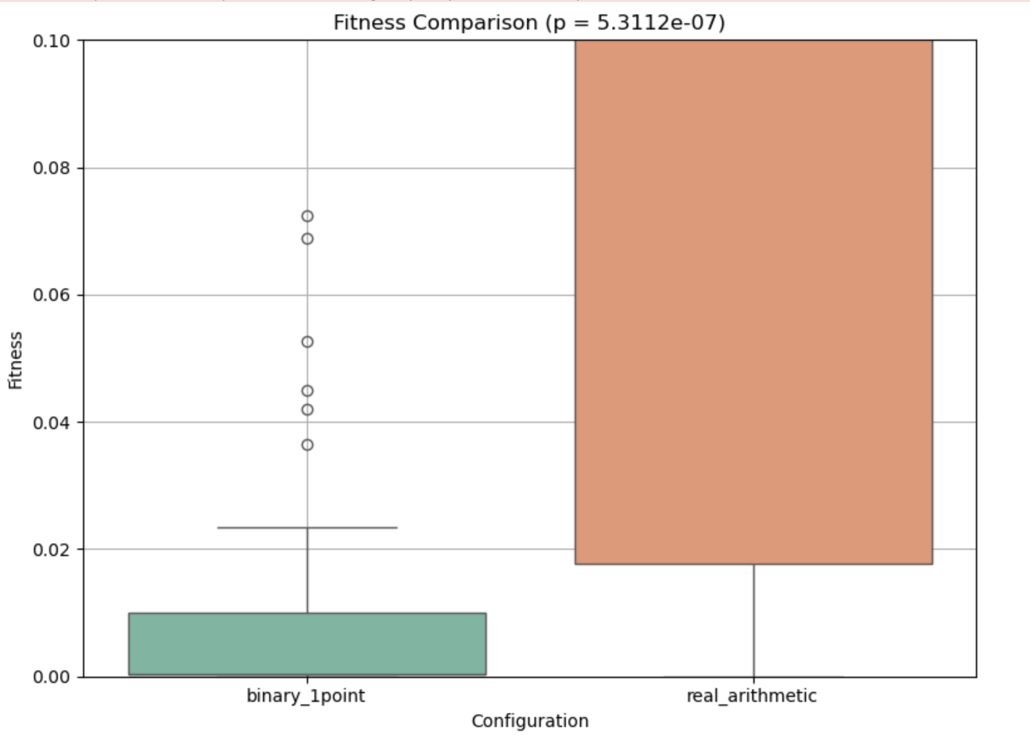
A direct comparison between binary 1-point and real arithmetic crossover methods shows:
T-statistic: -5.3064
P-value: 5.3112e-07
Binary encoding with 1-point crossover performs significantly better than real-valued encoding with arithmetic crossover(bacause p-value < 0.05)
This confirms the superior performance of binary 1-point crossover.

6. Conclusions
- Binary encoding with 1-point or 2-point crossover consistently outperformed real encoding.
- BLX crossover was more effective than arithmetic for real encoding.
- Larger populations led to more consistent convergence, especially on the Ackley function.
- Statistical analyses confirmed that encoding and crossover choices significantly impact GA performance.
- Binary encoding + 1-point crossover is the best configuration for strong exploitation—especially effective for deceptive, multimodal functions like Ackley.
-Real encoding + BLX introduces more exploration, which may help avoid local optima—but risks inconsistency without good selection or elitism.
Optimal GA performance requires a delicate balance of exploration and exploitation, and the results highlight this tradeoff clearly.

7. Improvements and Future Work
- Introduce adaptive mutation strategies to improve exploration.
- Test tournament or roulette selection to analyze selection pressure effects.
- Explore hybrid GA approaches with local search.
- Evaluate scalability by applying GA to higher-dimensional versions of the functions.
- Compare convergence speed and diversity metrics.
- Investigate parallel implementations for faster optimization.
- Extend analysis to additional benchmark functions for broader insight.

8. Appendix
- source code: Benchmark Functions.ipynb
- output files: ga_results.csv, schaffer_population_experiment.csv, ackley_population_experiment.csv

9. Sources
- https://www.sfu.ca/~ssurjano/schaffer2.html
- https://www.sfu.ca/~ssurjano/ackley.html

